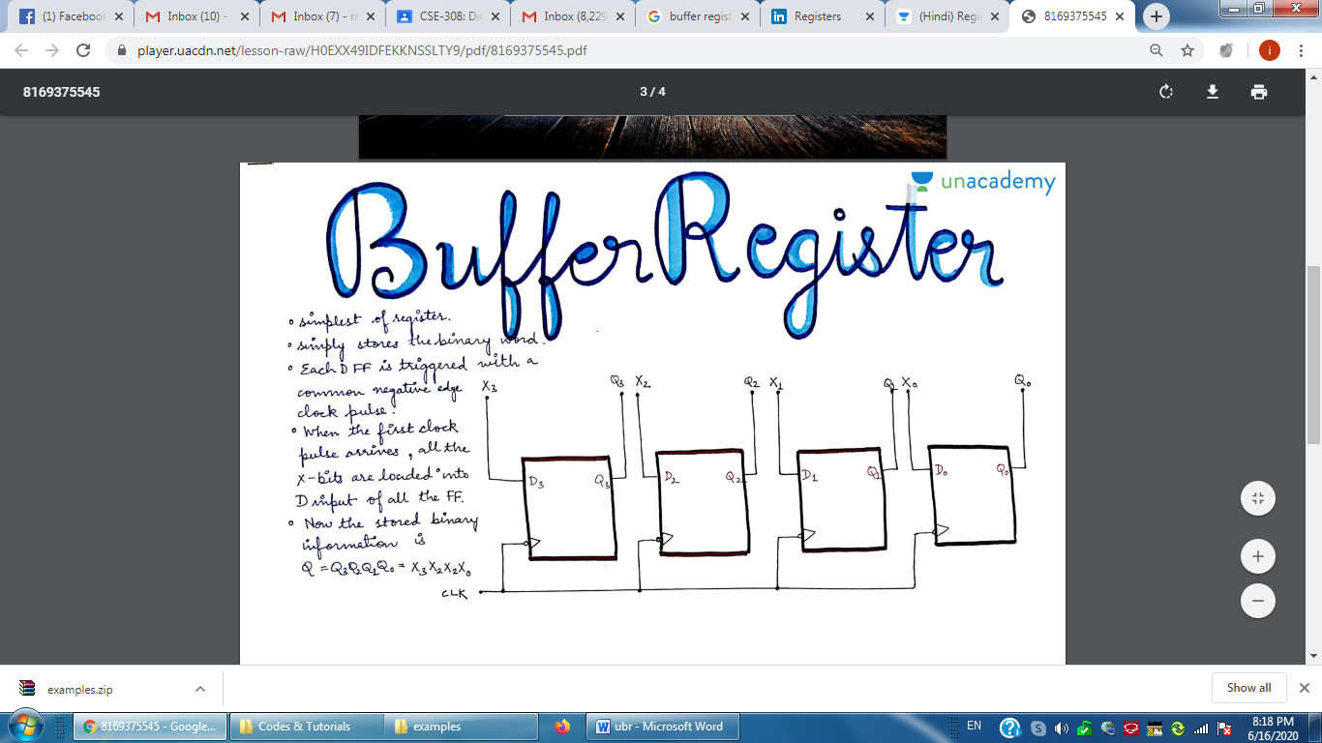
A 4-bit Uncontrolled Buffer Register

module ubr (CK, DIN, Q);

input CK;
input [7:0] DIN;
output [7:0] Q;

reg [7:0] Q;

always @ (negedge CK)
Q <= DIN;

endmodule

module test_ubr;

reg CK;
reg [7:0] DIN;
wire [7:0] Q;

ubr r1 (CK, DIN, Q);

always
#3 CK = ~CK;

initial
begin
CK = 0;
#5 DIN = 8'b10101010;
#8 DIN = 8'b11110000;
#17 DIN = 8'b00001111;
end

endmodule

